Application Form
2021 NCUE Summer Camp
“Culture & Chinese Learning Program in Taiwan”
- Personal Information
Family Name: |  | Given Name(s):
Gender: |  | Email Address:
Male Female
Nationality: |  | Date of Birth (YYYY-MM-DD):
Contact Address:( For sending material)
Contact phone number (country code- area code- phone number):
Batch selection
9th - 13th August 2021 (Batch1) | 16th - 20th August 2021 (Batch2)
- Education Information
Home University: | Education Level:
 | Undergraduate Postgraduate
School/Department: | Degree/Major:
Level of Chinese:
None Elementary Intermediate Professional Native
Level of English:
None Elementary Intermediate Professional Native
- Document Checklist
□ Application Form for 2021 NCUE Summer Camp
□ Declaration Form for 2021 NCUE Summer Camp
- Credit Card Authorization as a deposit.

Declaration Form

- CANCELLATION: (1) I understand that once accepted by the 2021 NCUE ONLINE SUMMER CAMP, I must give a 30-day notice, before the camp start date, of my intention to cancel. If no notice is given, I agree to pay the camp fee in full. (2) Also, no make-up class will be held, and no refund will be offered for class suspension due to force majeure or natural disasters such as typhoons earthquakes. (Course cancellation will follow the announcements by the Changhua County Government.) (3)Ｉunderstand that if I haven’t participated in the 2021 NCUE ONLINE SUMMER CAMP all the course, I will be charged the tuition fees: NT$ 3800/USD 136.
- RELEASE: By signing this form I release all members of NCUE staff and any other party involved in the organization and administration of NCUE from any liability as a result of any injury sustained during the 2021 NCUE ONLINE SUMMER CAMP. I grant permission for any photographs and videos taken at NCUE to be gratuitously used by NCUE or its representatives in displays or for advertising purposes.
- PRIVACY: NCUE requires an applicant to provide personal data including e-mail address, mailing address, telephone number, and credit card information in connection with participating in the 2021 NCUE ONLINE SUMMER CAMP. All such personal data is subject to protection under laws and regulations.
- ACCEPT OR REJECT: NCUE reserves the right to accept or reject any application for 2021 NCUE ONLINE SUMMER CAMP at its sole discretion without assigning any reason. Subject to the application form being duly and correctly completed and provided there are no queries to be raised by NCUE in connection with the application.

BY SIGNING BELOW, YOU CERTIFY THAT YOU HAVE READ THIS AGREEMENT, THAT YOU KNOW AND UNDERSTAND THE MEANING AND INTENT OF THIS AGREEMENT AND THAT YOU ARE ENTERING THIS AGREEMENT KNOWINGLY AND VOLUNTARILY.
Signature: Date:
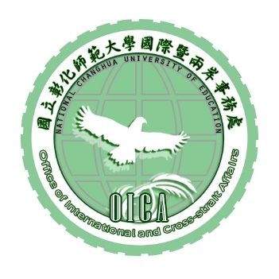
Parent/Guardian's signature:
(If the applicant is under 20 years old)

Applications cannot be accepted without a signature.

國立彰化師範大學國際處
OCIA, National Changhua University of Education.
信用卡繳費單Credit Card Authorization Form
姓 名  Name |  | 繳費日期  Date | / /  yyyy / m m / d d
班 別
Class
繳費金額  Payment | 新臺幣NT$ 3800 元整 Dollars
繳費方式  Type of Card | □ VISA  □ MASTER  □ 聯合信用
信用卡資料  Credit Card Information | 持卡人姓名(Name on credit card)：  卡號(Credit Card Number)：  □□□□-□□□□-□□□□-□□□□  發卡銀行(Issuing Bank)：  有效期限(Expiry Date)：□□ ∕ 20□□  商店代號： 44-250-0007-9 授權碼： （completed by NCUE）  持卡人簽名(Authorized Signature)：  （需與信用卡簽名一致Authorized Signature should match the signature on the back of the credit card）

